Spontaneous Emergence of a Mental Subject in Associative Distributed Memory Without Specialized Parts.
Tanyu Kolev "From the Perspective of Eternity – 2011" Association June 25, 2026
ABSTRACT:
Research into the topic of "technological personal immortality" hinges on conceptualizing the psyche—and the human psyche in particular—as a functional, self-organizing system of information existing within the memory space of associative distributed memory. The article "The Psyche as an System of Information " presents a hypothesis regarding the general nature of the psyche as a system. The psyche is depicted as a self-organizing, flow-type system of information, analogous to Bénard cells. In physical systems, Bénard convection cells are replaced here by associative vortices of diversity within the associative distributed memory of neural networks during the process of recognizing a new stimulus. The system's dynamics are determined by the neural network's temperature, which in turn depends on the sensory flow of diversity and its parameters. This hypothesis can be fully substantiated if it is explicitly demonstrated that the conditions for a non-equilibrium phase transition—occurring within the flow of sensory diversity entering the associative distributed memory—are met. The process of information self-organization leads to the emergence of a flow-type system information. Naturally, it must also be explicitly demonstrated that this type system of information successfully accounts for the four most general empirical characteristics of the psyche—characteristics applicable to any psychic phenomenon. This subject matter is also of interest within a broader context. In recent years, with the advent of artificial intelligence—and particularly the attempts to create synthetic intelligence—the topic of these systems acquiring a psyche, and especially consciousness, has become highly relevant. The perspective presented here can shed light on this issue.
It is an indisputable observation that the psyche emerges spontaneously—both in evolutionary terms and during the ontogenetic development of organisms. Yet, theorists in psychology and neurobiology have paid little attention to this observation. John Hopfield offers a heuristic hint by emphasizing that associative distributed memory should be an emergent property of neural networks. It is reasonable to hypothesize that a connection exists between the spontaneity of associative distributed memory and the spontaneous emergence of the psyche—a connection that warrants investigation and demonstration.
V.I. Kremyansky’s philosophical-methodological concept—which introduced the new term "systems of information"—links this type of system to the phenomenon of memory. The specific derivation of the "system of information" type from the characteristics of the implemented memory is significant and highly revealing, though it was formulated considerably later. In this article, building upon the results of previous analyses, I attempt to further develop and refine the characterization of the psyche as an system of information, drawing on specific models of distributed associative memory in neural networks.
First of all, I must highlight and substantiate a new aspect: the incorporation of sensory and effector channels into models of associative distributed memory as an essential and defining factor of this type of memory!
This perspective is not fully appreciated when analyzing the psyche-memory relationship; instead, the understanding of memory is primarily linked to inter-neuronal interaction and the fixation of the resulting traces. However, if we adopt the general definition of memory as "the transmission of information across the channel of time," then limiting the concept to traces of neuronal interaction proves insufficient. It is insufficient because it fails to account for reproduction as an integral aspect of memory—a process that entails both the generation of information (in the strict sense of the term) based on the sensory stream and the verification and correction of the generated information.
The structure and organization of sensory and effector channels are of key importance for the representation of associative distributed memory as a functional system —and, by extension, of the psyche as a self-organizing functional system of information.
Self-organization processes—whether in simpler systems (equilibrium phase transitions) or more complex ones (non-equilibrium phase transitions)—begin in a seemingly insignificant region; yet, over time, this region expands inexorably to become dominant. Crystallization starts with tiny crystal nuclei that rapidly grow to form the polycrystalline mass of the entire crystallizing substance. In the case of laser emission, the oscillation that initiates the coherent beam is initially lost amidst the chaos of all possible oscillations. However, under conditions of non-equilibrium energy pumping that exceeds a specific threshold, that particular oscillation—previously submerged among the multitude—begins to amplify rapidly, transforming into a dominant coherent beam that accumulates the system's total energy. There is every logical reason to assume that the self-organization of the "psyche" system emerges in an analogous manner. Naturally, when discussing an "system of information" the "crystal nucleus"—or more precisely, the oscillation destined to become dominant—is not electromagnetic in nature but rather an information "vortex." The models of distributed associative memory that serve as my starting point abound with such "vortices." T. Kohonen’s model simply treats such a vortex as an elementary cell of associative memory—a concept also inherent in John Hopfield’s notion of "collective computation" as an oscillation around a specific attractor. In the distributed associative memory of neural networks, represented by the "spin-glass" model, there is an immense number of attractors and associated state oscillations; yet, the starting point of self-organization is clearly significant. Whether the process begins at one memory-state attractor or another will largely determine the entire cluster of subsequently evolving states—and, by extension, the psyche that emerges from this self-organization.
Higher mental functions, such as consciousness and self-awareness, differ quite distinctly from elementary mental processes—sensation, perception, emotion, etc.—yet in terms of their mode of existence (i.e., ontologically), they are one and the same. Regarding the ontology of intracerebral processes, the mode of existence of consciousness does not differ substantially from that of the ordinary psyche. Of course, the qualitative leap involved in the emergence of consciousness is immeasurably greater than the preceding leap—from irritability to mentality. The conscious psyche possesses informational and control (cybernetic) capabilities that—both qualitatively and quantitatively—far exceed those of the ordinary psyche; nevertheless, consciousness remains a specific instance of the psyche. To understand this phenomenon, the trajectory of mental development—from the most elementary psyche to the conscious psyche—must be explicitly delineated. The cognitive process cannot proceed without establishing a starting point—specifically, by precisely formulating the conditions for the emergence of the most elementary mental subject. The problem of the spontaneous emergence of a mental subject within an associative distributed memory—absent evolutionarily refined neural network mechanisms—can also be framed in this way.
There are observations so familiar to us—and so taken for granted—that they rarely become the subject of scientific analysis or the basis for scientific conclusions. One such observation is the spontaneous emergence of the psyche during ontogenesis, ranging from the most elementary forms to the highest and most complex: the human psyche. It is considered a trivial fact that in every instance—that is, in every process of ontogenesis—the psyche emerges spontaneously and is uniquely individual, even while adhering to the species' general characteristics. The development of the psyche depends on the "structure" and developmental stage of its immediate substrate—the specific individual's nervous system—but also on its own development as an system of information, a factor of no less significance. Moreover, the more developed the psyche itself becomes, the greater the degree of individuality and originality. As the pinnacle of psychic development, the human psyche demonstrates maximum uniqueness—both phylogenetically and individually—existing within a single, unrepeatable representative. Despite attempts to devise typologies, classifications, and general descriptions, there are unequivocally no two identical human psyches!
Is there an explanation—a psychological or psychophysiological theory—in which the spontaneous emergence of the psyche is a natural consequence of the theory's foundational premises, rather than an *ad hoc* hypothesis? Can the spontaneous emergence of the psyche, along with its originality and uniqueness, be interpreted from a unified perspective? The emergence of the psyche as a system is inextricably linked to the emergence of a psychic subject. Can the psychic subject also be interpreted within the framework of the theory's foundational premises and concepts?
I maintain that the examined models of associative distributed memory can successfully address the questions at hand if the sensory and effector streams of diversity are incorporated into them as a natural part of the neural networks' memory! This entails not analyzing the specific content of the diversity stream, but rather taking into account its general structure, which could be relevant to the questions raised.
The conceptual framework established by models of associative distributed memory leads directly to the conclusion that the incoming sensory stream (originating from both the external and internal environments) induces changes in the "memory landscape." Alongside the sensory stream, "valleys" (or "attractors") emerge, corresponding to the encoding of the initial, more enduring, and repetitive stimuli. Empirical observations across various species indicate that these first encoded stimuli are crucial for shaping an individual's behavior, as they serve as the initial memory reference points for recognizing subsequent sensory input. Processes such as initial recognition and generalization take shape around these primary attractors. The phenomenon of imprinting has been extensively documented and studied, revealing that in certain species, it plays a pivotal role in the formation of psyche and behavior. However, the significance of these very first sensory traces should not be overstated. In more advanced psychological systems, the continuous flow of sensory information and the drive for behavioral adaptation to both internal and external environments tend to diminish the relative importance of those initial stimuli and their encoded traces. At the same time, these very factors highlight another essential primary structure—one that does not negate the effects of imprinting but rather integrates them into a broader framework.
The intuitive hypothesis here is that the sensory stream and its requisite general structure play a decisive role in the emergence of the psyche, regardless of the species' level of evolutionary advancement. Evolutionary developments are significant for the specific types of psyche, rather than for the emergence of the psyche in the most general sense. Two components are responsible for the emergence of the mental: the presence of an associative distributed memory organized in a centralized manner, and a periphery consisting of sensors and effectors. I will demonstrate that by working with the concepts and properties of associative distributed memory models, one can naturally and logically transition to the concepts and properties associated with the most general understanding of the mental.
The novelty (or the discovery!) lies in the observation of a common, essential feature within such a simple system. Despite the immense diversity of the sensory stream, in every individual instance where a psyche spontaneously emerges, there is something invariably constant, stable, and recurring. We can express it this way:
Signals arriving from all sensors are organized within a precisely defined "coordinate system"—namely, the specific individual organism, comprising its nervous system and its periphery. This coordinate system serves as a strictly individual condition for the perception of external stimuli and their subsequent interpretation.
Of course, the term "coordinate system" is metaphorical, borrowed from geometry and physics. It implies that all sensors belong to a specific individual who occupies a precise position in space and time, and whose sensors possess a specific modality. Yet, the analogy with the concept of a "coordinate system" is significant because, in both instances, there is an origin for the dimensions. Beyond the standard dimensions of time and space—which have a clearly fixed zero point—this zero point serves as the origin for other dimensions defined by the various senses: tactile, visual, auditory, thermal, olfactory, and so forth. The coordinate system is multidimensional, with the number of dimensions determined not only by geometric parameters but also by the available sensory modalities. The zero point is defined by the individual's emergence.
The individual moves through space-time, and their coordinate system moves along with them. The stream of diversity entering from the sensors—along with the effects of the individual's own behavior—is always perceived and evaluated relative to their generalized, multidimensional coordinate system. The environment (both external and internal to the individual) inevitably includes certain recurring and relatively invariant stimuli. These "constant" stimuli, in turn, provide an opportunity for the individual's "coordinate system" to manifest and be evaluated within the memory system. Essentially, constant stimuli inevitably create their own attractors on the energy-information surface representing the neural network's free energy. Yet, the set of these attractors implicitly contains information about the "coordinate system" that reflects these influences. One could say that the cumulative effect of these relatively constant inputs induces a general, integrated curvature of the energy-information surface, leading to the formation of an additional valley. Prolonged exposure within the memory system—alongside the "constant, recurring" attractors—results in the formation of a distinct attractor representing the multidimensional coordinate system itself. The stream of diversity entering the associative memory contains sufficient information about the perceiving and evaluating "coordinate system" to generate an indirect yet highly significant memory trace: the attractor of the "coordinate system" itself.
At any given moment and in every one of its parts, the stream of sensory inputs carries information indicating that it originates from a single system of sensors—one uniquely defined in terms of space, time, and all axes associated with the various sensory modalities. Some of these "axes" are oriented toward the organism's internal environment, while others reflect the external environment and the organism's own behavior within it. There is a feedback loop involving the effector apparatus (muscles, glands, etc.) and a reflection of the spatiotemporal effects resulting from the movement being performed. A distributed associative memory equipped with sensors and effectors possesses all the necessary conditions to form a stable memory trace—not only of recurring external stimuli but also of "itself" and its own internal environment. A central role in this process is played by the distributed associative memory's capacity to generalize and form prototypes. When the constant component of the sensory stream (the coordinate system generating it) is considered alongside the associative memory's ability to not merely record incoming images but to create prototypes—that is, to generalize and identify commonalities among stored images—an intriguing picture of the process emerges. It does not unfold as a linear, one-time act; rather, it operates through feedback and resembles a "vortex" of associations. Moreover, each intermediate result is stored and subsequently triggers new associations (the Kohonen model!), given that the sensory stream is continuous under normal conditions. Inevitably, over time—as sufficient traces accumulate and undergo associative "vortex-like cycling"—a "valley" will form in memory, corresponding to the "coordinate system."
A new prototype will emerge and establish itself—one that is qualitatively different from all the others.
This generalized, primal prototype arises from the fact that all stored inputs are created and interpreted within the individual's specific and unique "coordinate system." This represents the common aspect of all inputs received by the memory since the very inception of its functioning. Once established, the "prototype" of this specific "coordinate system" within the associative memory undergoes a process of self-focusing and deepening with each subsequent input. This "deepening" can be understood in both a literal and a figurative sense, as the "valley" formed within the energy-information landscape of the associative memory constitutes the deepest and most enduring trace. Furthermore, it serves as the common "precursor" to all subsequent memory states as the network's temperature decreases.
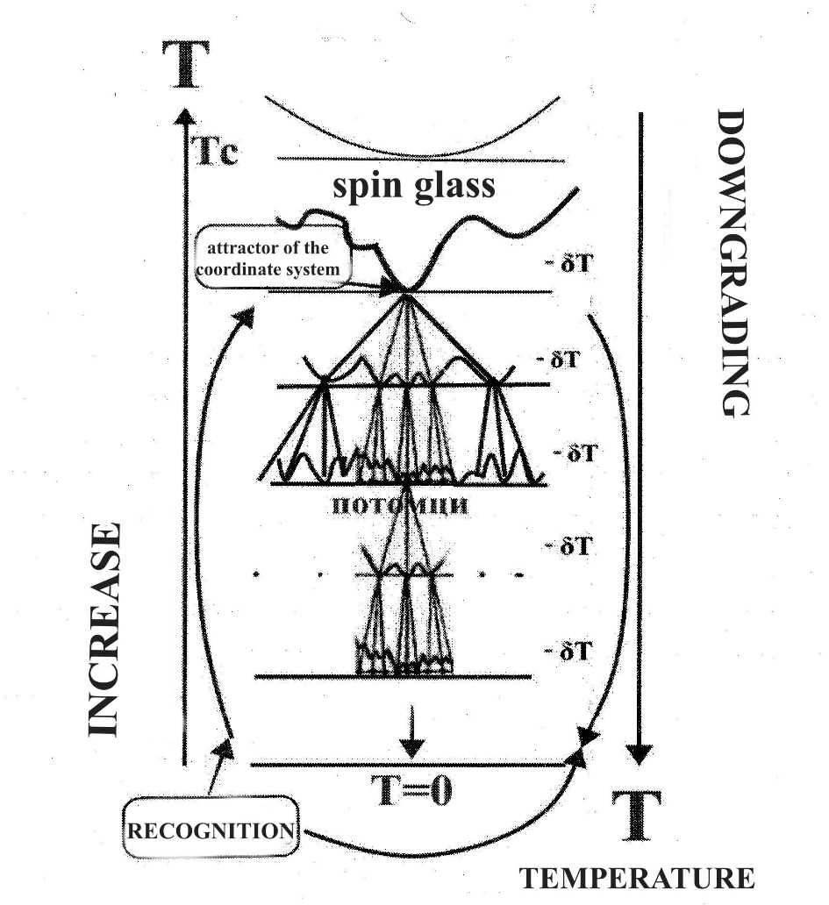
Fig.№2
A key feature is that, once the process of forming memory traces begins, a primary associative loop—driven by this deepest attractor—starts to function; this loop remains continuously active, as it is triggered by every association. Each elementary recognition process involves either finding something close or common to an image already present in memory or—if the input is incomparable to anything existing—creating a new "valley." However, the recognition process unfolds within the cluster formed by the coordinate system's attractor. This process transforms incoming diversity into information possessing intrinsic meaning, as the content is evaluated against the existing cluster. The emergence of this primary associative loop—and the consequent construction of the entire associative memory system—inevitably bears its imprint.
While the portion of memory formed prior to the emergence of the attractor in question can be interpreted as neurological, the memory formed after its emergence possesses different qualities and can be considered *psychic* memory! It is entirely justifiable to equate this constantly active loop within associative memory—this most enduring and deeply fixed memory trace—with the concept of the "psychic subject"! The subject is not merely the deepest, most permanent memory trace, but also a process of recognizing, classifying, and organizing incoming stimuli, as well as expanding memory itself. It is the most dynamic and indispensable subsystem within the entire system of information. It is precisely this subsystem that transforms the diverse sensory stream into "information in its pure form", manifesting all the properties inherent to the psychic realm: projection, the ideal mental image, and an activity that is not reducible to activity within the environment but constitutes an autonomous "free" activity, among others.
In essence, the formation of memory as a system—occurring after the emergence of the psychological subject and with its assistance—represents a transition from the physiological to the psychological. It is a transition from stimulus and reflex to mental image and psychological memory. Memory, which until that point had been neurological, transforms into psychological memory following the emergence of this persistent associative vortex. Here are the reasons:
*₁.
Self-organization occurs when several conditions—well-described in numerous publications—are met. These are:
- The system is open in the thermodynamic sense, i.e., it exchanges matter and/or energy with the environment;
- The dynamic equations describing the system are nonlinear;
- The deviation from equilibrium exceeds certain critical values;
- The elements exhibit cooperative (coherent, coordinated) behavior.
Each of these conditions must be interpreted through the lens of the concept of information systematicity in order to speak of information self-organization and the emergence of a specific type of self-organizing system of information. Associative distributed memory represents a form of stored diversity, yet it must be demonstrated that it can be viewed as a functional self-organizing system of information. Although these conditions were derived for physical systems, the fact that self-organization processes are substrate-independent means they can be successfully applied not only to structural processes but also to hyperstructural ones—that is, to phenomena such as signals and information.
First condition: The system is open in the thermodynamic sense.
An system of information—considering its substrate—is open in the thermodynamic sense because it exchanges variety with the environment via sensors and effector organs. Its "substrate" is precisely variety (and information as reflected variety). The specific elements constituting the system do not matter; self-organization occurs independently of the "material" of the elements. In systems of information , substrate independence manifests at a second level, because information can be encoded and re-encoded across different substrate carriers.
Second condition: The dynamic equations describing the system are nonlinear.
Nonlinearity is clearly evident even at the level of the "elementary cell" (or atom!) of the associative memory. In the Kohonen model, the elementary cell of the associative memory is built upon a pronounced feedback mechanism and could not function without it. Nonlinearity is inherent to the nature of associative memory. As a thermodynamic system, the "spin glass" is non-ergodic. At temperatures below the critical point, the behavior of the variables describing the system exhibits pronounced memory and path dependence—implying significant nonlinearity—which constitutes the essence of the model.
Third condition: The deviation from equilibrium exceeds certain critical values.
This condition relates directly to the quantitative characteristics of the sensory stream of variety. In terms of both quantity and quality, the sensory input to memory must not fall below a certain critical value. This condition has been repeatedly verified through sensory deprivation experiments. Hallucinations and other anomalous effects associated with sensory deprivation occur once the sensory stream is restricted to levels that can be interpreted as a threshold. Psychological anomalies are observed only when the individual's degree of isolation reaches the requisite level. It can be hypothesized that this represents the "lower critical limit" of the amount of variety entering the system. There is likely also an "upper limit" for this same stream, which would trigger a different mode of psychological functioning.
Fourth condition: The elements exhibit cooperative (coherent, coordinated) behavior.
For physical systems, this condition is met almost automatically, as they are all composed of specific constituent particles—atoms, molecules, etc.—which are inherently quantum-mechanical objects. Quantum mechanics ultimately points to a "unified, non-mechanistic, indivisible whole" within the world; thus, these constituent particles share a unified nature and foundation that manifests under certain conditions. However, diversity—and specifically diversity understood as content (i.e., information in the true sense)—is not a quantum-mechanical phenomenon. The fourth condition requires a more detailed analysis to understand self-organization in the emergence of information-based systems.
he analysis may begin with the central thesis of M. Bushev’s impressive article, in which he argues that quantum mechanics is not merely a theory of micro-objects but also possesses a macroscopic nature. Bushev starts by critiquing the notion—developed by P. Dirac—that "micro-object" and "quantum object" are one and the same. In reality, however, the concept of a quantum object is far broader, encompassing not only micro-objects but also macro-objects and even mega-objects of astronomical scale. Examples of macro-quantum phenomena include superconductivity, superfluidity, quantum vortices, laser emission, the Josephson effect, and—in a much more general sense—the presence of long-range order within systems. Through a careful and detailed analysis of these phenomena, Bushev concludes that they all stem from the same fundamental principle underlying modern quantum mechanics:
"No matter how diverse the phenomena of quantum macrophysics may appear, their essence is one and the same: long-range order, wherein the laws of quantum mechanics prevail over the laws of chance. The system's macro-state is a repeated, macroscopic replication of a single quantum-mechanical micro-state. The system transitions into this new state spontaneously, acting as a unified whole..."
The requirement for coherent (cooperative, coordinated!) behavior among the elements is, in essence, the fundamental reason for the emergence of structures in dissipative systems under conditions of strong non-equilibrium. Under such conditions—characterized by critical fluxes of matter or energy—the unified quantum-mechanical nature of the elements (such as atoms or molecules in physical systems) manifests itself, causing them to respond to external influences in a unified (coherent) manner. Without acknowledging the shared nature of the molecules, the emergence of order and structure in Bénard convection cells—a classic example of a self-organizing flow system—would appear to be an impossible miracle. The probability of billions of molecules moving in a correlated and coordinated fashion without direct interaction is vanishingly small. Long-range order, wherever it appears, is the consequence of a mechanism that must inherently be rooted in the properties of the very particles constituting the system.
If Bushev’s position is adopted, the concept of the self-organization of information requires a specific interpretation of the "quantum" unified basis underlying the self-organization process. Regarding the "vortices" of associations and their self-organization, uncovering the reason for their "coherence" is of paramount importance. In essence, this constitutes the fundamental basis for the spontaneous emergence of information within the memory of the psychic system.
The content of any unit of information—not merely as a bit, but as a portion of diversity or a wave front originating from an object—always inherently carries the characteristics of the perceiving system. This perceiving system is the individual's multidimensional coordinate system, which shapes a distinct and profound "valley" within the landscape of associative memory. With each new portion of diversity and through every process of recognition and generalization, this valley deepens. As the temperature cycles, the cluster within its hierarchical tree expands, developing more branches and new levels. Content recognized within the stream of diversity is separated, classified, and generalized from a unified standpoint, thereby transforming into information. This information is organized to populate the emerging, holistic picture of the environment—both internal and external—which becomes increasingly precise and rich over time. The units of diversity entering memory (acting as wave fronts and the basis for image formation) share a unified nature and foundation; this unity stems from the already established "embryonic crystal"—the attractor of the specific coordinate system belonging to the individual, who is thus transformed into a subject. It is precisely this region of states within the distributed associative memory that recognizes and classifies incoming diversity, converting it into discrete portions of information grounded in a unified basis. This valley within memory is unique in its spatiotemporal characteristics and sensory modalities, serving as the unified basis for every unit of information that undergoes a phase transition to become an system of information. This constitutes the "quantum unified basis" for the stream of diversity arriving from the sensors, transforming it into a "coherent" structure for the newly emerged subject. The process unfolds amidst the non-equilibrium conditions of this diversity stream. These units of diversity align based on their unified basis—specifically, their emergence within this "coordinate system" and their decoding therein—thereby becoming "coherent" relative to it. Their unified basis becomes manifest, and they form a unified picture for this specific subject—and no other. The self-organization of these diversity units entails decoding—that is, comparison with the existing picture of reality—and memorization, transforming them into memory traces. Yet, these memory traces are ordered and organized according to their informational content and serve this specific subject; thus, they constitute information *for* the subject. Moreover, this is information in its "pure form"—a picture of reality that is continuously supplemented and refined. An information structure is formed, implying a specific arrangement and synthesis aligned with that unified basis: the subject. Incoming information undergoes recognition and segregation; it is stored within pre-existing "image-valleys" or creates new ones if the incoming stimulus is entirely unfamiliar. An ultrametric hierarchical tree is constructed based on the overlapping of stored stimuli, which transform into mental images linked together into a cohesive whole!
The overall picture of internal and external reality manifests through the system's temperature dynamics. These dynamics depend, on the one hand, on the incoming flow of diversity, which raises the temperature, and on the other, on the active operation of memory acting as a "processor"—performing separation, recognition, and generalization, and thereby lowering the temperature. The process is cyclical—involving a continuous rise and fall in temperature—and this, in turn, triggers a multitude of associations that are themselves circular or "vortex-like" in nature. Among all these associative vortices, there is one that is constant, central, and dominant, and which connects to all the others.
It is precisely this that can be interpreted as the presence of a psychic "subject" existing alongside and in parallel with all other associations. The central cell, around which all the others emerge, also constitutes the primary "driving force" of the entire self-organization process. Each informational "cell" in the flow contains within itself the fundamental element common to all—namely, this specific subject, and no other.
*_{2.}
The process of self-organization of information within associative distributed memory begins in the region of memory states that I have termed the "coordinate system attractor." While the analogy to a seed crystal in the crystallization process is largely valid, the phase transition occurring in neurological memory involves a specific feature that must be highlighted from the outset. The requisite general structure of sensors and effectors presents another characteristic that must be taken into account. Some sensors and effectors are oriented toward the organism's external environment, while others are directed toward its internal environment—addressing homeostasis as well as the preparation and execution of behavior. This division of sensors and effectors based on orientation proves significant for the formation of the psyche as a self-organizing system of information.
Likely, as early as the first "descendants" within the hierarchy of states of the psyche cluster, a distinction was made between the flow of diversity originating from the internal environment and that coming from the external environment. Recognizing signals as distinct based on the criteria of "internal" versus "external" is the primary condition for the emergence of the psychological phenomenon known as the "sense of self" and for the formation of information regarding the boundary between the organism and the external environment. The attractor within the coordinate system acquires a "sense of self"—a quality that sharply distinguishes it from all other attractors in memory. The emergence of a "sense of self" fully justifies designating this attractor as a "psychic subject." Naturally, throughout the evolutionary process, the sense of self undergoes various refinements, manifesting in higher animals and humans as self-awareness—that is, the "Self." Essentially, based on these same characteristics of the memory system, an additional boundary emerges in humans: the boundary between the psyche and the organism, rather than merely between the organism and the external environment.
The sense of self enables the evolutionary process to establish a system of reward and punishment, manifested through the emergence of positive and negative emotions. Details regarding this motivational system, viewed through the lens of the systems-information approach, can be found in the publications of P.V. Simonov. Crucial to this analysis is the fact that th.e psyche—emerging within memory—is not merely a self-organizing system of information, but a *functional* self-organizing system of information that serves the survival of both the organism and itself. Functionality implies the activation of feedback during the process of evolutionary refinement, based on the achievement of a specific result. It is not a one-time act of self-organization, whether in ontogenetic or phylogenetic terms. Achieving a specific result proves pivotal to the system's emergence, existence, and development. The result always possesses concrete manifestations and dimensions.
*_{3.}
The most significant outcome of the existence and functioning of associative distributed memory is the emergence of a distinct picture of reality—both internal and external—for the system. The nature of associativity is such that all memory states exhibit a certain degree of overlap—that is, they share something in common or are linked by specific criteria. When one adds hierarchical organization and varying levels of generalization—such as the creation of prototypes with differing degrees of commonality—the hierarchical tree structure that emerges, originating from the "coordinate system's" attractor, is essentially a picture of the reality revealed to that coordinate system. It is a picture continuously enriched by every act of memorization, one that undergoes generalization at various levels and is tested for adequacy during the system's overall survival process.
The essence of this picture of reality—formed within an associative distributed memory that undergoes a phase transition to become a psyche—is best illustrated by the phenomenon of psychic projection. As L.M. Vekker emphasizes, this "ultra-specific and extraordinarily mysterious spatial attribute of the psychic"—projection—manifests itself even in the simplest psychic process, sensation, operating on an "all-or-nothing" principle. Philosophers, psychologists, and physiologists have long noted this characteristic, and it continues to command their attention to this day. Processes occurring within the organ of the psyche manifest as events unfolding outside that organ—in real space and time, within the realm of objects—a space that clearly does not coincide with the space occupied by the organ itself. While there are other instances where the qualities of one object are reproduced in another—such as in modeling or the creation of mock-ups—these forms of reproduction fail to capture the specific nature of mental reproduction. The uniqueness of the mental image lies in the fact that, upon emerging within the organ of the psyche, it is projected—or superimposed—onto the real objects it reproduces with varying degrees of accuracy, as well as onto the spatiotemporal relationships between those objects; it thus creates a "scene" of specific breadth and depth, yet remains "virtual" or "illusory," composed of neither matter nor fields.
The phenomenon of projection, as a characteristic of the psyche, is well illustrated by examples involving visual perception and optical illusions, which clearly demonstrate the distinction between reality and the projected mental image. Projection is present in the most primal forms of mental activity, such as tactile sensation. It emerges at the very boundary of the psyche, concurrent with the mental process itself; as the psyche develops, it simply undergoes certain modifications, gaining greater clarity and distinctness. This phenomenon has been well described, and rigorous measurements and substantial evidence have been presented regarding optical illusions! However, I am unaware of any publications offering a meaningful and logically consistent explanation—let alone one linked to the theory of associative memory in neural networks.
From the perspective of fixed associative distributed memory models that have undergone self-organization—viewed as a functional system of information —one can formulate a sufficiently clear and logical explanatory concept, which could subsequently be refined and developed in greater detail.
It is worth recalling Kohonen’s scheme, which illustrates associative storage and retrieval within the holographic process. Naturally, the emphasis here is on "associative memory" rather than its specific implementation as a holographic process; holography merely visualizes this characteristic.
In the demonstrated associative storage of two objects, A and B, when B is reconstructed using the trace on the hologram and the beam reflected from A, a phantom image emerges—not at an arbitrary location in space, but precisely where object B was originally situated, and with its exact dimensions and characteristics.
I must emphasize that an observer is required to perceive the phantom image! In the schemes cited as examples, the observer is external—namely, the experimenter. The process of reproducing object B is a form of projection. The image of B appears exactly where object B was originally located and matches the real object in size. While this process strongly resembles psychological projection, it is not, of course, psychological projection itself. Nevertheless, it embodies the heuristic principle that explains psychological projection! Perhaps a more precise term would be "elementary process"—the foundation upon which the full-fledged phenomenon of psychological projection later emerges.
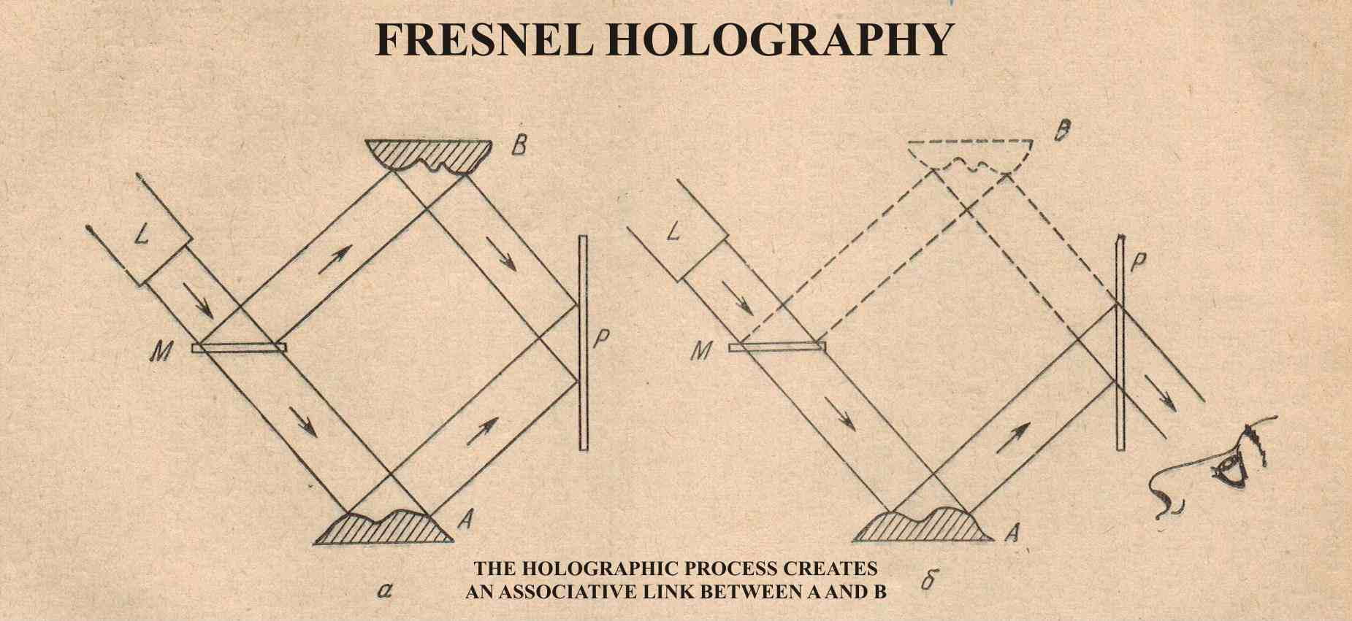
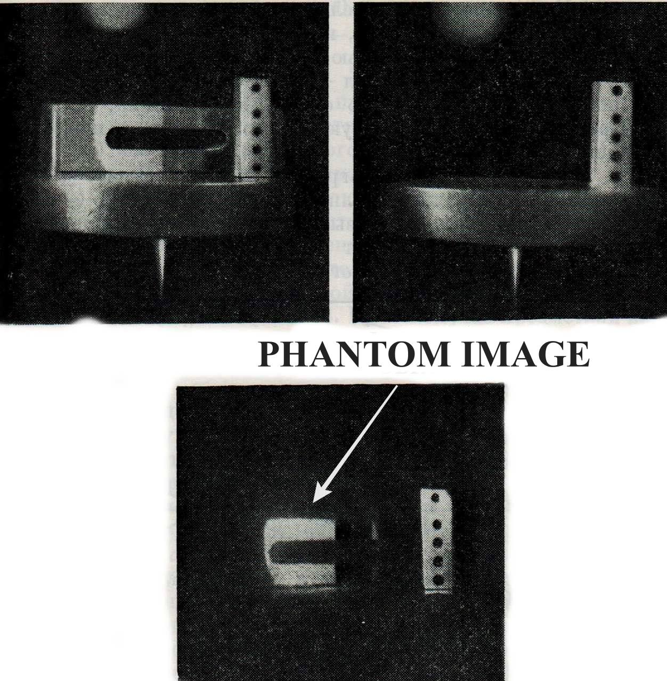
Fig.№3
Indeed, the diagram illustrates an elementary process of associative memory and reproduction, clearly demonstrating that even in such a basic form, the associative process possesses a property that reflects the most essential characteristics of psychological projection.
The most crucial aspect of this elementary process is associative memory, rather than the holographic plate itself. The key to achieving the effect lies in the code—the information stored on the plate (specifically, the information derived from the interference of the two wave fronts originating from objects A and B, transformed into an interference memory trace). The holographic model of associative distributed memory can be viewed as a "first approximation" of the "spin-glass" model of that same memory. While the processes for encoding memory traces are analogous, the spin-glass model introduces dynamics and a cascade of non-equilibrium phase transitions, which facilitate self-organization and collective computation within the memory. It is logical to attempt to elaborate on this concept within the more precise associative memory model derived from the unique properties of the spin-glass phase.
One can begin with the stage of comparing stored inputs with a newly arriving input. Essentially, this is a recognition process in which collective computation isolates the new input and compares it against the attractors existing in memory. It is important to note that these do not encompass all possible attractors within the entire memory; rather, they are limited to those reflected in the hierarchical state tree of the attractor formed within the individual's coordinate system—that is, the emergent psychological subject. Two scenarios are possible: either recognition (full or partial) occurs, and the stimulus is assigned to a pattern already stored in memory; or the stimulus is entirely unfamiliar, in which case it gives rise to a new "valley." Recognition is a typical associative "vortex" process that proceeds—via the activation of "information cells" or "information cycles"—first through prototypes and subsequently through more detailed specifications. Often, the "temperature" rises initially (because the stimulus acts as noise) and then drops as the system spontaneously finds the path to the "valley" containing the complete information through collective computation. The speed of neurophysiological processes within the neural network determines the rate at which information cells cycle and the speed at which the required valley is discovered. The progression of this process is also influenced by the ratio of active information vortices (or cells) to those that are less active yet still in motion. A crucial factor is the total amount of memory—that is, the number of traces fixed in associative memory—which determines the volume of less active information vortices (representing the subconscious and subconscious predispositions). A stimulus recognized by the sensors is transformed into information for the mental subject because its place within the existing mental picture has been identified and its quantitative characteristics have been assessed. Alongside the process of recognition, information in a "pure" form emerges, as the impact is evaluated and classified—both qualitatively and in terms of spatiotemporal parameters—within the subject's pre-existing information system. This constitutes the spatiotemporal picture of the situation in which the subject finds itself. It is important to emphasize that this information in its "pure" form does not exist as a physical image, but rather as an imaginary (virtual) image observed by the subject—that is, by the previously established system of information. "Projection" is the process of comparing the pre-existing "virtual" picture of the situation—constructed by the subject, and within which the individual exists and acts—against incoming sensory input. This new input triggers a new sensation, perception, and so forth—that is, new associative processing within the memory-processor—followed by a renewed comparison and the superimposition of an image onto the real environment; in other words, a new act of projection. Projection is not a one-time event but an active, cyclical comparison of the incoming sensory stream with the system of information stored in memory. "Projection" has likely proven to be the most effective method for making the rapid, accurate behavioral adjustments needed to cope with swift environmental changes—adjustments crucial to the individual's survival. This is the point at which to once again raise important questions—and address their far-from-trivial answers:
Who creates the "ideal" mental images!?
Who extremely rapidly recognizes and "decodes" incoming sensory information from the external and internal environments, generates information in its "pure" form—that is, creates mental images—and "projects" them in such a way that they fit perfectly into the entire context in which the system operates!?
These questions usually elicit a deeply flawed and misleading answer—primarily from materialist scientists! The answer is typically: it is the central nervous system—the brain, or specific neural networks within it! (With the caveat that, while we do not yet fully understand the "neurodynamic" code of the psyche, we are poised to decipher it and solve the problem once and for all!) The answer is something else entirely:
No, it is not the brain—with its neural networks—that "decodes" sensory information and creates "ideal" mental images, nor is it what carries out the process of "projection" and recognition; rather, this is performed by a system of a new type—the psyche's self-organizing system of information! This system emerges on the foundation of the neural network (whether simply or complexly organized), yet it requires the accumulation of stored impressions driven by the continuous flow of sensory input. A process of self-organization of information takes place, giving rise to a system of a qualitatively new type at a hyper-structural level. Memory transforms from a neurophysiological phenomenon into a mental one, and a new level of reality emerges: subjective reality.
Responsible for this leap is the spontaneously emerging entity—the embryonic crystal around which a new type of system forms: an information system known as the psyche. Upon reaching a certain level of accumulation, the fixed traces undergo generalization, resulting in the formation of a dominant associative vortex common to all. It is this vortex—by developing its own cluster of states—that is capable of "decoding" the sensory stream, forming mental images, and generating information in its "pure" form (not for anyone else, but for itself!). It "projects" the resulting image—that is, it recognizes it and assigns it a place within the memory system, which has by now become a psychic one. The psyche, as a self-organizing information system, can be viewed as a hierarchically organized image existing virtually. The hierarchically organized levels of this image are positioned within an ultrametric space and vary in their degree of generalization or specificity regarding both spatial and temporal parameters. Furthermore, they are neither static nor immutable; rather, they are influenced by the incoming sensory stream while preserving information that remains invariant and adapted to the environment. Through the associative process of recognition, every element of this image contributes to the construction of the mental image and its projection.
Conclusions:
1. The concept of the spontaneous emergence of a psychic subject within an undifferentiated neural network is based on a synthesis of the Hopfield and Kohonen models of associative distributed memory and is presented here in its preliminary working form.
2. Even in this form, however, it offers a concept of a primary psychic subject possessing all the qualities necessary to be genuinely classified as a psyche, rather than as a physical or physiological entity.
3. The psychic subject introduced in this way possesses the capacity to project mental images as a natural consequence of the properties of associative distributed memory.
4. This concept offers opportunities for further refinement and development in various directions, as well as for application to the understanding of diverse mental processes, including self-awareness, consciousness, imagination, thinking, and so forth. The models can be validated through computer simulation.
Sources used:
- Anokhin P.K., Principal questions of the general theory of functional systems, 1973, https://www.klex.ru/nxn
- Bushev M., The Macroscopic Nature of Quantum Mechanics, in the collection Methodological Problems of Quantum Mechanics, Sofia, 1979, pp. 132–148.
- Collier R.J., Burchardt Ch. B., Lin L.H., Optical Holography, 1971, p.433
- Dubrovsky D.I., Information, consciousness, brain, M., 1980 ;The problem of the ideal, M, 1983.
- Ebeling V., Formed structures in irreversible processes, M., 1979.
- Gorman Chris, Anthony Robins, Alistair Knott, Hopfield networks as a model of prototype-based category learning: A method to distinguish trained, spurious, and prototypical attractors, 2017, v.91, p. 76-84. (Забележка: Оригинално записан като Chris Gorman, подреден по фамилия Gorman)
- Haken, H., „Synergetics: An Introduction“ (1977)
- Horn Gabriel, Memory, Imprinting, and the Brain, Oxford Press, 1985, (руски превод: Память, импринтинг и мозг (Исследование механизмов),1988г.)
- Kohonen Teuvo, Associative Memory, A System-Theoretical Approach, Springer-Verlag, 1978
- Kolev T., Personal Immortality Without Mysticism and Religion, 2011;
- Kolev T., "Philosophy of Technological Personal Immortality," Vol. 1, Model, 2025.
- Kremyansky V.I., Methodological problems of the systematic approach to information, Moscow, Nauka, 1977. (Забележка: Оригинално записан като V.I. Kremyansky)
- Lilly John C., "The Deep Self: Profound Relaxation and the Tank Isolation Experience" (1977); (Забележка: Изваден от общата позиция 23)
- McAlister Hayden, Anthony Robins, Lech Szymanski, Prototype Analysis in Hopfield Networks with Hebbian Learning, 2024. (Забележка: Оригинално записан като Hayden McAlister, подреден по фамилия McAlister)
- Nicolis, G. & Prigogine, I. „Self-Organization in Non-Equilibrium Systems“(1977);
- Petrov S., Methodology of the Substrate Approach, Nauka i Izkustvo, Sofia, 1980
- Simonov P.V., The Emotional Brain (Nauka, Moscow, 1981), The Motivated Brain (1987), The Creative Brain (1993). Collection: Experimental Neurophysiology of Emotions (1972)
- Tank D.W., Hopfield D.J., Collective calculations in neuro-like electronic circuits, magazine "In the world of science", 1988, No. 2, p. 51. («Scientific American», 1987, No. 6, v. 257)
- Vekker L.M., Volume I "Psychic Processes", 1974;
- Vekker L.M. – "Psychic Processes", Vol. 3 (1981).
- Zubek John P., "Fifteen Years of Research" (1969); (Забележка: Изваден от общата позиция 23)
Други ресурси:
- https://tanyukolev.eu/?p=625 , https://subspecieaeternitatis.org/bg/?p=653

First published in the monograph „Philosophy of Technological Personal Immortality“ by T. Kolev (2025).
Mentioned by L.M. Wekker, Volume I "Psychic Processes", 1974.
Tank D.W., Hopfield D.J., Collective calculations in neuro-like electronic circuits, magazine "In the world of science", 1988, No. 2, p. 51. («Scientific American», 1987, No. 6, v. 257)
V.I. Kremyansky, Methodological problems of the systematic approach to information, Moscow, Nauka, 1977.
Kolev T., Personal Immortality Without Mysticism and Religion, 2011; Kolev T., "Philosophy of Technological Personal Immortality," Vol. 1, Model, 2025.
https://tanyukolev.eu/?p=625 , https://subspecieaeternitatis.org/bg/?p=653
L.M. Vekker – "Psychic Processes", Vol. 3 (1981).
Anokhin P.K., Principal questions of the general theory of functional systems, 1973, https://www.klex.ru/nxn
https://tanyukolev.eu/?p=625 , https://subspecieaeternitatis.org/bg/?p=653
Petrov S., Methodology of the Substrate Approach, Nauka i Izkustvo, Sofia, 1980, p. 230.
https://tanyukolev.eu/?p=625 , https://subspecieaeternitatis.org/bg/?p=653
Such an analysis makes sense for psychological research proper, whereas here we are seeking the connection to the psychic as such.
Horn Gabriel, Memory, Imprinting, and the Brain, Oxford Press, 1985, (руски превод: Память, импринтинг и мозг (Исследование механизмов),1988г.)
"Emergence" can take the form of birth, hatching, or any other mode of reproduction for species possessing a psyche, as well as the creation of an artificial nervous system based on a non-biological substrate (such as neuromorphic chips connected to suitable non-biological sensors and effectors).
To illustrate: an object undergoes mechanical motion, tracing a specific trajectory. Assume it periodically captures images of its surroundings. Continuous photography—or imaging at a sufficiently high frequency—yields a series of pictures containing information about the environment as well as data that allows for the reconstruction of the object's trajectory. While each image captures a static view of the landscape, it also implicitly conveys information about the specific location from which the shot was taken. A sequence (or stream) of images captured while in motion—relative to fixed, permanent reference points—allows for the precise and easy determination of the photographer's movement: how they are moving, their exact position relative to the landscape, and the specific quantitative parameters of the motion. It is well known that associative distributed memory is capable of making such generalizations and successfully solving such problems.
J. Hopfield, D. Tank, Collective Computation With Continuous Variables, DOI:10.1007/978-3-642-82657-3_16 ,1986, Hayden McAlister, Anthony Robins, Lech Szymanski, Prototype Analysis in Hopfield Networks with Hebbian Learning, 2024, Chris Gorman, Anthony Robins, Alistair Knott, Hopfield networks as a model of prototype-based category learning: A method to distinguish trained, spurious, and prototypical attractors,2017, v.91, p. 76-84,
Dubrovsky D.I., Information, consciousness, brain, M., 1980 ;The problem of the ideal, M, 1983.
Glansdorff, P. & Prigogine, I. , „Thermodynamic Theory of Structure, Stability and Fluctuations“ (1971); Nicolis, G. & Prigogine, I. „Self-Organization in Non-Equilibrium Systems“(1977); Haken, H., „Synergetics: An Introduction“ (1977); Nicolis, G. & Prigogine, I., Exploring complexity,1989; Эбелинг В., Образования структур при необратимых процессах, М.,1979г.( Ebeling V., Formed structures in irreversible processes, M., 1979.)
Information in the true sense of the word, where the content is the determining factor, rather than merely the quantity.
The thesis that self-organization processes are substrate-independent (i.e., they obey universal mathematical and physical laws, regardless of whether the medium is physical, chemical, biological, social, or computational) is a foundational principle of several interdisciplinary sciences: synergetics, chaos theory, complex systems theory, and cybernetics.
John P. Zubek, Fifteen Years of Research" (1969); John C. Lilly, "The Deep Self: Profound Relaxation and the Tank Isolation Experience" (1977);
I am not aware of studies of this type.
Бушев М., Макроскопична същност на квантовата механика, сб. Методологически проблеми на квантовата механика, София, 1979г.,стр.132 – 148.;( Bushev M., The Macroscopic Nature of Quantum Mechanics, in the collection *Methodological Problems of Quantum Mechanics*, Sofia, 1979, pp. 132–148.)
Bushev M., The Macroscopic Nature of Quantum Mechanics, in the collection *Methodological Problems of Quantum Mechanics*, Sofia, 1979, pp.146.
Bushev M., *ibid.*! This understanding is also incorporated into Bushev’s later monograph, *Synergetics* (St. Kliment Ohridski University Press, 1992).
There is a distinct analogy with the self-organization of biological cells, which organize themselves into tissues and organs. What all cells have in common is genetic information... In the case of mental images self-organizing into a unified picture, the common element is the presence of a mental subject shared by all memory traces within the mental memory system.
Collection: *Experimental Neurophysiology of Emotions* (1972); Simonov P.V., *The Emotional Brain* (Nauka, Moscow, 1981), *The Motivated Brain* (1987), *The Creative Brain* (1993).
Anokhin P.K., *Fundamental Questions of the General Theory of Functional Systems* (1973); *Principles of the Systemic Organization of Functions* (Nauka, Moscow, 1973, pp. 5–61). https://www.leonarus.ru/wp-content/uploads/Functional.pdf
Веккер Л.М., Психические процессы, т.1, Лен. ,1974г., стр.12(Vecker L.M., Psychic processes, item 1, Len. , 1974, p. 12).
*Perception* (collection of papers), Moscow: Mir, 1974, pp. 262–274; Rock, I., *Introduction to Visual Perception*, Vol. 1, Moscow, 1980, p. 57. We all know that the Moon appears much larger on the horizon than at the zenith, yet few people realize that this difference is not due to an optical effect, but rather to how our nervous system—while processing visual perception—projects the image of the Moon onto the sky! Precise measurements show that the optical image of the Moon is identical at the horizon and at the zenith; however, the mental image projected onto the actual Moon differs, as it is conditioned by the background.
The scheme in part a/ reflects a real experiment and is taken from Collier R.J., Burchardt Ch. B., Lin L.H., Optical Holography, 1971, p.433; the scheme in part b/ is a schematic reflection of the same experiment on associative memory borrowed from Kohonen T., Ассоциативная память, Mir, 1980, p. (Kohonen Teuvo, Associative Memory, A System-Theoretical Approach, Springer-Verlag, 1978;

